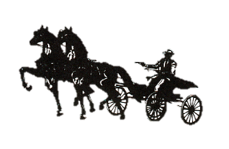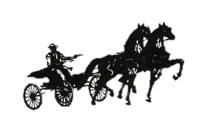

CANADIAN ROAD HORSE ASSOCIATION
THE STANDARDBRED JOURNAL ROADSTER CLASSIC TO BIKE

2026 SHOW CONFIRMATION FORM

Owner
Name: | Phone #

Address:

Email:

Trainer
Name: | Phone #

Address:

Email:

Horse – nomination 1
Show Name
Name of Horse Show/Fair
Name of Horse Show/Fair

Horse – nomination 2
Show Name
Name of Horse Show/Fair
Name of Horse Show/Fair

Declaration:

I, , confirm that the above nominated horse(s) competed in a harness class at a minimum of 2 horse shows/fairs as listed above in the current calendar year.

Completed form must be postmarked on or before October 22nd, 2026 and mailed to the address below in order to be eligible for the Standardbred Journal Roadster Classic to Bike at the Royal Agricultural Winter Fair.

Mail OR Email:

Helen Thomas
2858 South Grimsby Rd. 20, Smithville,
Smithville, ONT, L0R 2A0
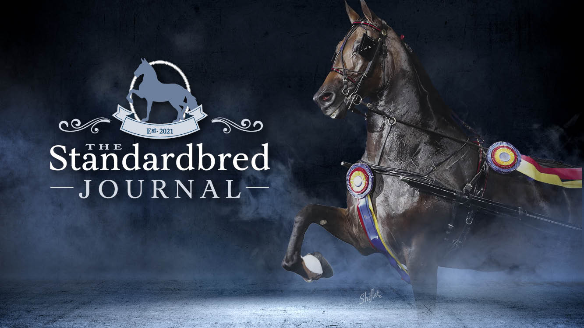remlap49@hotmail.com

